Module – 6 Python – Collections, Functions and Modules

- Accessing List
- Indexing in lists (positive and negative indexing).
Positive Indexing:
- Positive indexing starts from 0 for the first element of the list.
- The index increases by 1 for each subsequent element.
- For a list of n elements, the valid positive indices range from 0 to n-1.
Negative Indexing:
- Negative indexing starts from -1 for the last element of the list.
- The index decreases by 1 for each preceding element, moving towards the beginning of the list.
- For a list of n elements, the valid negative indices range from -1 (last element) to -n (first element).

- Lab: Write a Python program to create a list with elements of multiple data types (integers, strings, floats, etc.).
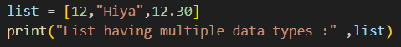

- Write a Python program to access elements at different index positions.
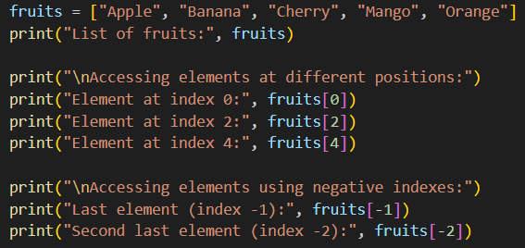
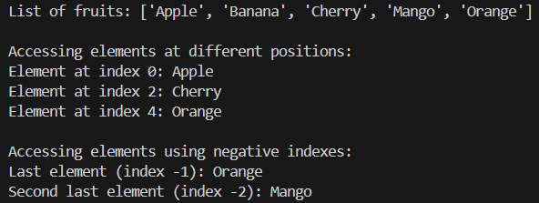
- Write a Python program to find the length of a list using the len() function.
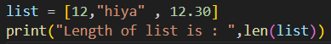

- List Operations
- Common list operations: concatenation, repetition, membership.
  - List Concatenation (+) :- You can join (combine) two or more lists using the + operator.
  - List Repetition (*) :- You can repeat the elements of a list multiple times using the * operator.
  - Membership (in, not in) :- You can check whether an element exists in a list using in or not in.

- Understanding list methods like append(), insert(), remove(), pop().
  - Append Method - Adds an element to the end of the list here index value of new added list will be continued from first list.
  - Insert Method - inserts the specified value at the specified position.
  - Remove Method - removes the first occurrence of the element with the specified value.
  - Pop Method - removes the element at the specified position.

- Lab: Write a Python program to add elements to a list using insert() and append().
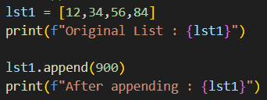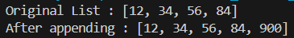
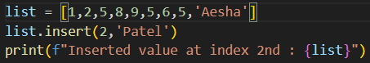

- Write a Python program to remove elements from a list using pop() and remove().
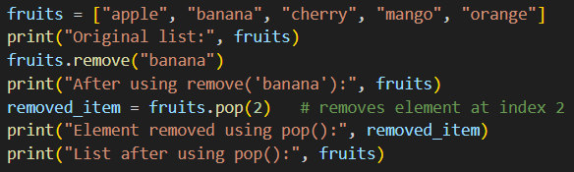
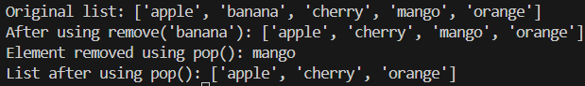

- Working with Lists
- Basic list manipulations: addition, deletion, updating, and slicing.
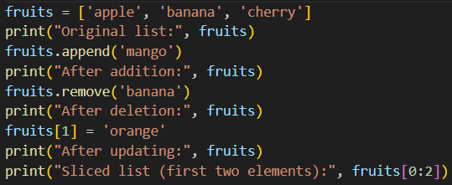
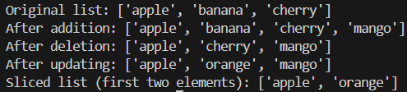

- Lab: Write a Python program to iterate over a list using a for loop.
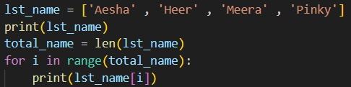
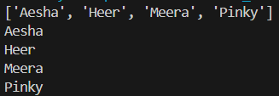

- Write a Python program to sort a list using both sort() and sorted().
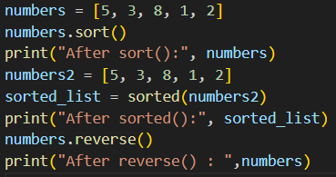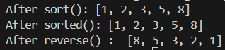

- Write a Python program to insert elements into an empty list using a for loop and append().
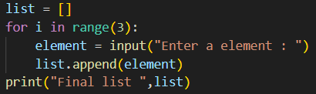
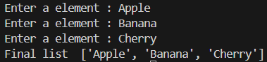

- Tuple
- Introduction to tuples, immutability.
A tuple is similar to a list, but it cannot be changed after creation.
This property is called immutability — meaning you cannot add, remove, or modify elements in a tuple.
Eg :- my_tuple = (10, 20, 30, 40)
print("Tuple:", my_tuple)
output :- Tuple: (10, 20, 30, 40)

- Creating and accessing elements in a tuple.
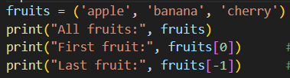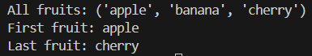
- Basic operations with tuples: concatenation, repetition, membership.
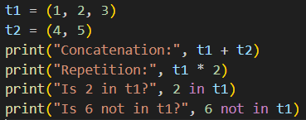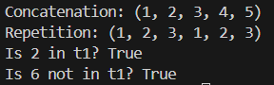

- Lab: Write a Python program to create a tuple with multiple data types.
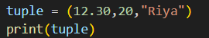

- Write a Python program to concatenate two tuples.
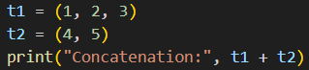

- Write a Python program to convert a list into a tuple.
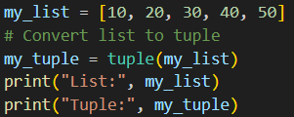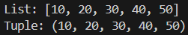

- Write a Python program to access the value of the first index in a tuple.
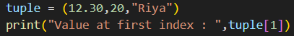

- Accessing Tuples
- Lab :- Write a Python program to access values between index 1 and 5 in a tuple.
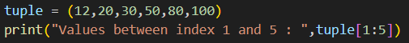

- Write a Python program to access alternate values between index 1 and 5 in a tuple.

- Write a Python program to access the value from the last index in a tuple.
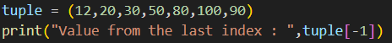

- Dictionaries
- Introduction to dictionaries: key-value pairs.
- A dictionary in Python stores data as key–value pairs.
- Each key is unique, and it is used to access its corresponding value.
- Dictionaries are written using curly braces {}.

- Accessing, adding, updating, and deleting dictionary elements.
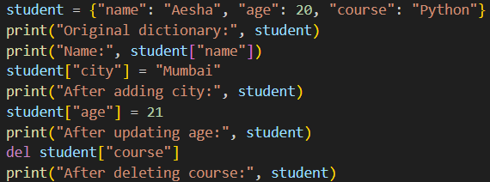
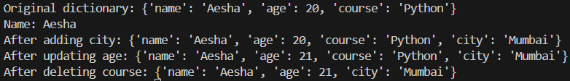

- Dictionary methods like keys(), values(), and items().
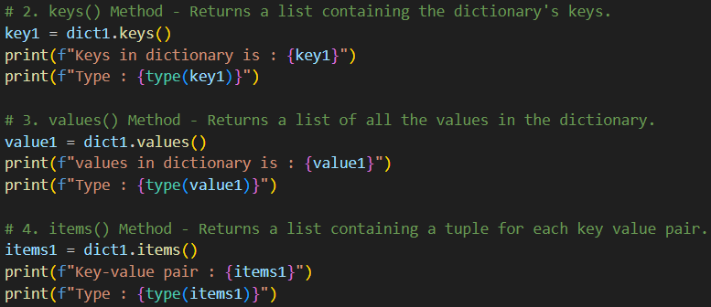
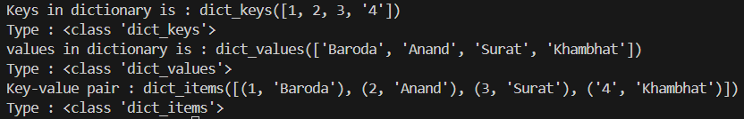

- Lab :- Write a Python program to create a dictionary with 6 key-value pairs.
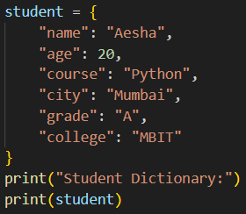

- Write a Python program to access values using dictionary keys.
Same student dictionary used
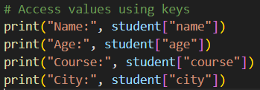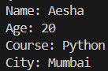

- Working with Dictionaries
- Iterating over a dictionary using loops.
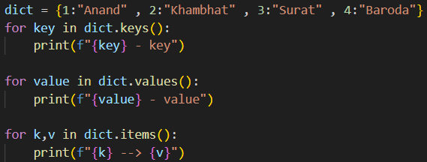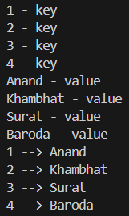

- Merging two lists into a dictionary using loops or zip().
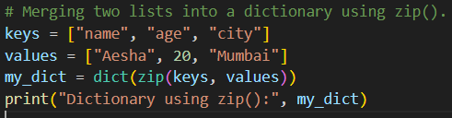

- Counting occurrences of characters in a string using dictionaries.
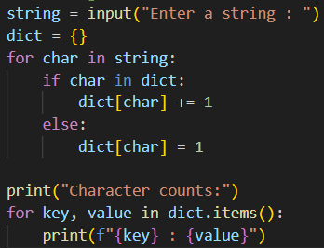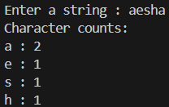

- Lab :- Write a Python program to update a value in a dictionary.
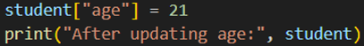

- Write a Python program to merge two lists into one dictionary using a loop.
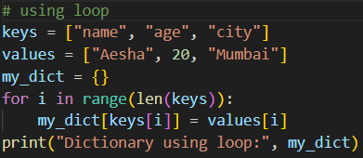

- Write a Python program to separate keys and values from a dictionary using keys() and values() methods.
Done in theory
- Write a Python program to count how many times each character appears in a string.
Done in theory

- Functions
- Defining functions in Python.
A function is a block of reusable code that performs a specific task.
It helps make programs shorter, cleaner, and easier to manage.

- Different types of functions: with/without parameters, with/without return values.
Example 1: Function without parameters
def greet():
print("Hello, welcome to Python!")
greet()
Output :- Hello, welcome to Python!

Example 2: Function with parameters and return value
def add(a, b):
return a + b
result = add(5, 3)
print("Sum:", result)
Output :- Sum : 8

Example 3: Function with default parameter
def greet(name="Aesha"):
print("Hello,", name)
greet()
greet("Heer")
Output :- Hello, Aesha
Hello, Heer

  - Function without return value :- It performs a task but doesn’t send back a result.
def greet(name):
print("Hello,", name) # Just prints the message
greet("Aesha")

- Lab :- Write a Python program to create a function that takes a string as input and prints it.
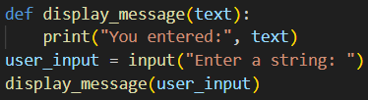

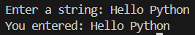

- Write a Python program to create a calculator using functions.
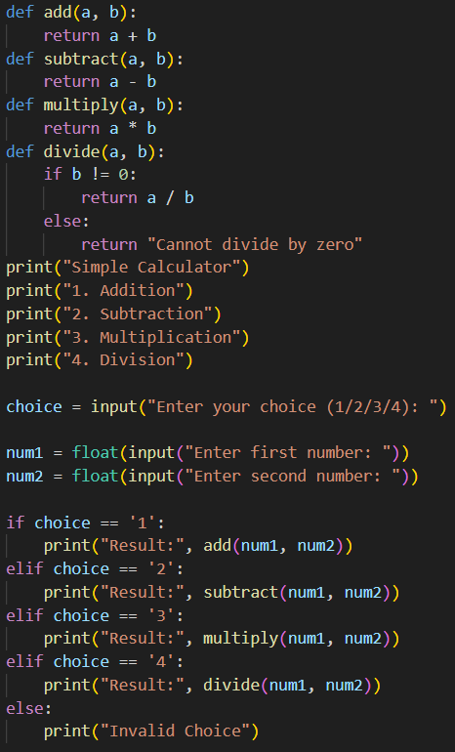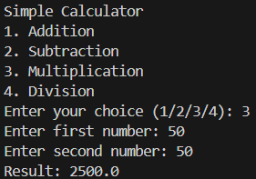

- Write a Python program to create a parameterized function that takes two arguments and prints their sum.
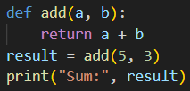

- Write a Python program to create a lambda function with one expression.

- Write a Python program to create a lambda function with two expressions.

- Modules
- Introduction to Python modules and importing modules.
A module in Python is simply a file containing Python code — functions, variables, or classes — that you can reuse in other programs.
It helps in organizing and reusing code efficiently.
- Types of Modules :-
- Built-in modules – already included with Python (e.g., math, random, datetime)
- User-defined modules – created by the programmer.

- import module_name → imports the entire module.
- from module_name import function_name → imports specific items.
- as → lets you rename a module for convenience (e.g., import math as m).

- Standard library modules: math, random.
1. math Module
- Purpose :- The math module provides mathematical functions like square roots, powers, trigonometry, logarithms, etc.

2. random Module
- Purpose :- The random module generates random numbers — useful for games, testing, or simulations.

- Creating custom modules.

- Lab :- Write a Python program to import the math module and use functions like sqrt(), ceil(), floor().
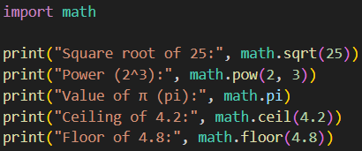
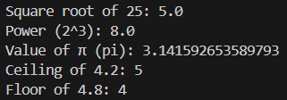

- Write a Python program to generate random numbers using the random module.
